Lab #4: Invoice Generator
  - Karson Dahl
  - 10/19/2024

  - Algorithm
This program will be generating an invoice. Files needed are House.h, House.cpp, Room.h, Room.cpp, and main.cpp.The constant variables for the cost per gallon, cost per mile, cost per can of paint, and hour rate per coat will be in the class (House.h). To start, it will use getline for the invoice name, prompt for the max number of rooms to be painted, and prompt user for the distance from the office. Create a House class with classes for Rooms inside, which includes paintable area via length, height, and width. A switch case will be used for the three functions, for adding (a), listing (l), and quitting (q). This switch case will utilize toupper to avoid frustrating char errors. Check if the maximum number of rooms has been reached; if it has, output an error message when A is selected in the switch case and let the user continue looping. The add option will add a room to the current house, using the code from Lab 2 for Room.h and Room.cpp. This room will be passed by reference into the roomVect vector that stores room objects. Perform numeric error checking in main re-prompting the user if input is invalid. The class should not prompt users to re-enter information. The list option will list all of the rooms, allowing the user to see how much they have already done while still allowing them to continue. The readout should display all prior values for the room, volume, paintable area, and the gallons of paint required (using ceil). This function will use the showData function from the Room.cpp, with minor formatting changes and improvements that make it more applicable for this. The final switch case option q will exit the user from the looping of adding or listing rooms, and will print the final invoice. In the final invoice, include labor charges (number of rooms, hourly rate, and the labor subtotal), product charges (paint cans required, cost per paint can, and amount per room), and travel charges (miles away from the store, rate per mile, and total for travel). Dollar signs should only be placed on the subtotals and the final total. A final prompt with a ‘y’ or ‘n’ switch case for whether or not the user would like to print to a file will be initiated, and do as instructed.

  - Screen-Shots of Running Program
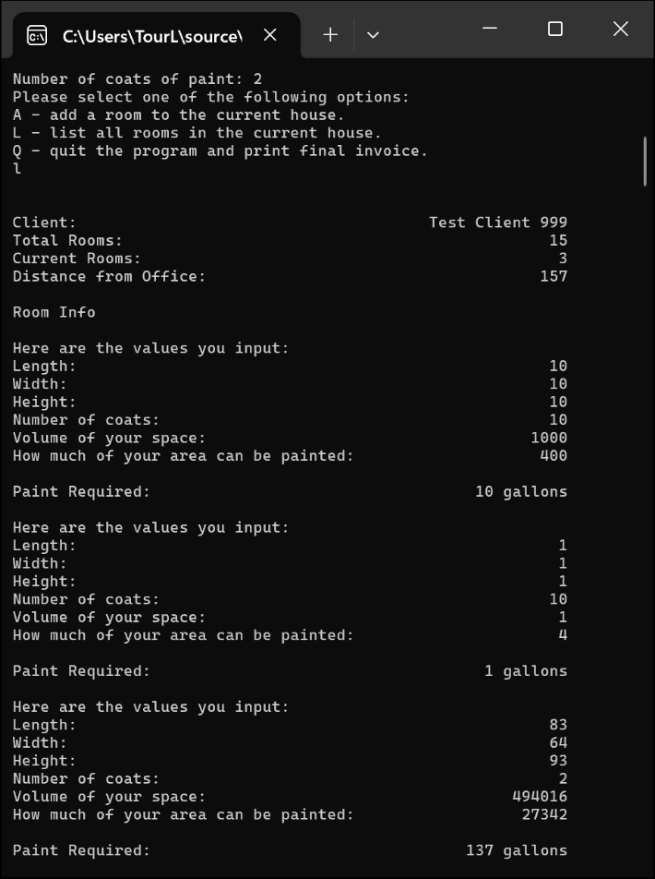
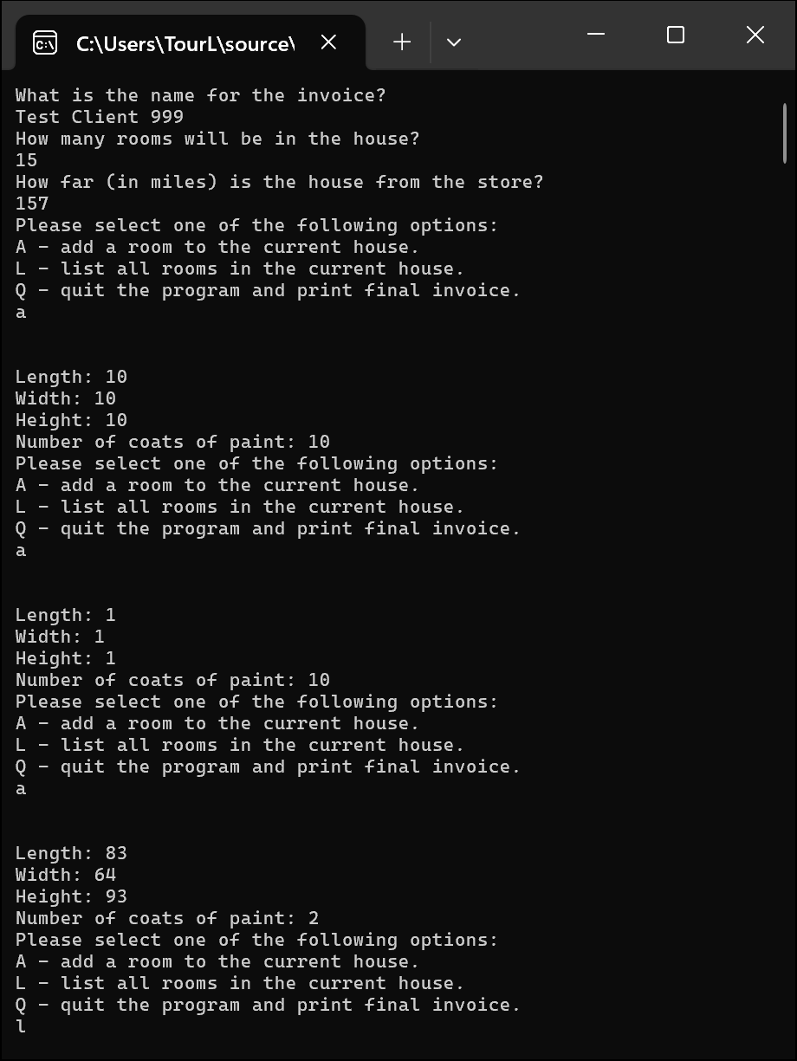
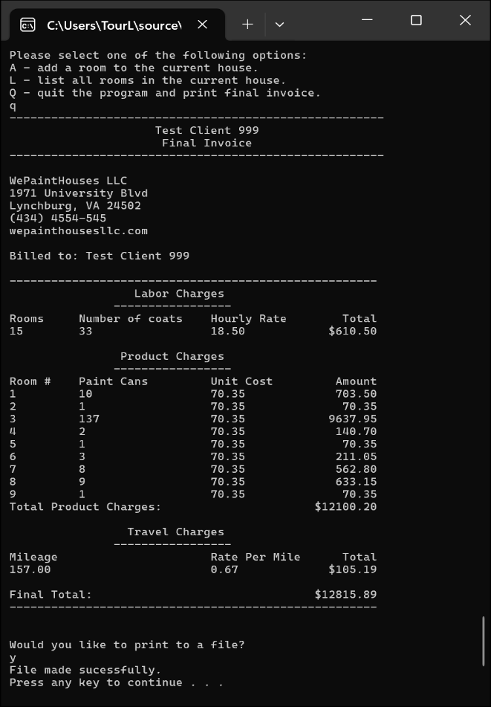
  - Integrity Statements
As a protective measure, WePaintHouses LLC has also asked you to verify the integrity of your code with every project. This is a liability measure to ensure that no copyright issues occur down the road, and that you have not broken the contract terms and used outside code. To this end, please make sure that the following integrity statements are included in every submission:
- I have not shared the source code in my program with anyone other than the pre-approved human sources.
  - Please include a note here if you have used one or more of the pre-approved human sources or received special permission from me.
- I have not used source code obtained from another student, or any other unauthorized source, either modified or unmodified.
- If any source code or documentation used in my program was obtained from another source, such as the course textbook or course notes, that has been clearly noted with a proper citation in the comments of my program.
  - It would also be helpful to include a note here of which sources you used
- I have not knowingly designed this program in such a way as to defeat or interfere with the normal operation of any machine it is graded on or to produce apparently correct results when in fact it does not.
Note: These statements serve as your personal promise that the above is true. If I find that you have not been true to ALL of the four statements above, you will get a zero for the assignment and receive an academic violation report (which goes on your academic record). Both are minor compared to the loss of your integrity.
  - Change Orders
This section will not apply to all submissions, but inevitably there are some students that wish to take a solution one step further than the directions and/or accomplish the solution in a different manner than intended. If that is the case for one of your labs, you must get prior permission from me before submission. This is to make sure that the integrity of the assignment is maintained and that any changes do not result in one or more of the learning outcomes being missed.
If you wish to modify one or more portions of a given submission, you must first set up an office appointment with me to discuss. This allows me to evaluate whether the proposed change would still measure the same objectives. Together, we will come up with an altered scope of work for the assignment, which I will ask you to include here. I encourage creativity! Please feel free to make these assignments your own, we just need to use a bit of caution to make sure you are still learning the required concepts.

